Ex. No. 1 | JAVA LOOPS
YouTube Link
Date of Exercise | DD.MM.YYYY

Aim
To understand and implement various loop constructs (for, while, do-while, for-each) in Java for repetitive execution of code blocks.

Description
Loops in Java are control flow statements that allow a block of code to be executed repeatedly based on a boolean condition or for a specified number of iterations. They are fundamental for automating repetitive tasks, processing elements in collections (like arrays or lists), and implementing algorithms that require iteration. Java provides four main types of loops: the `for` loop (including the enhanced `for-each` loop), the `while` loop, and the `do-while` loop, each suited for different scenarios based on when the loop condition is evaluated and the number of guaranteed executions.

Program
// FileName: LoopDemonstration.java
public class LoopDemonstration {
public static void main(String[] args) {
System.out.println("--- Java Loop Demonstration ---");
// 1. For Loop: Repeats a block of code a specific number of times.
// Prints numbers from 1 to 5
System.out.println("\n1. For Loop (1 to 5):");
for (int i = 1; i <= 5; i++) {
System.out.print(i + " ");
}
System.out.println();
// 2. While Loop: Repeats a block of code as long as a condition is true.
// Prints numbers from 1 to 3
System.out.println("\n2. While Loop (1 to 3):");
int count = 1;
while (count <= 3) {
System.out.print(count + " ");
count++;
}
System.out.println();
// 3. Do-While Loop: Repeats a block of code at least once, then as long as a condition is true.
// Prints numbers from 1 to 2
System.out.println("\n3. Do-While Loop (1 to 2):");
int j = 1;
do {
System.out.print(j + " ");
j++;
} while (j <= 2);
System.out.println();
// 4. Enhanced For Loop (For-each loop): Iterates over arrays or collections.
// Iterates through an array of strings
System.out.println("\n4. Enhanced For Loop (Iterating an array):");
String[] fruits = {"Apple", "Banana", "Cherry"};
for (String fruit : fruits) {
System.out.println(fruit);
}
System.out.println("\n--- End of Demonstration ---");
}
}

Output Screenshot
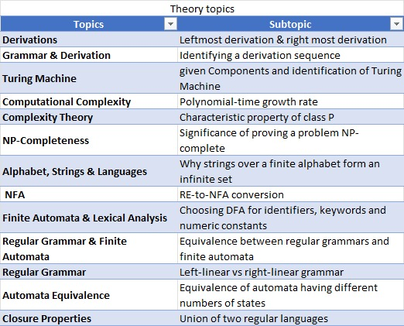

Result
The experiment successfully demonstrated the implementation and behavior of `for`, `while`, `do-while`, and enhanced `for` loops in Java. The output confirmed that each loop construct effectively controlled the repetitive execution of code blocks according to its specific condition and iteration mechanism, thereby achieving the objective of understanding Java loops.

